

**Asset Practice Answers: Mathematics**

1. In Mihir's class, students sit in order according to their roll number. The places of Roll number 1 to

Roll number 12 are shown below.

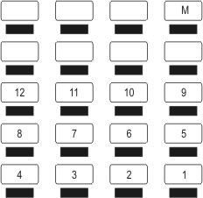

The place marked 'M' is Mihir's seat. What is his roll number?

A. 13

**B. 17**

C. 20

D. 29

2. Rashi thinks of a number. Anar has to guess Rashi's number.

Rashi gives the following hints to Anar: - The number has 4 as one of its digits. - The number is greater than 300 and less than 400.

Which of these could be Rashi's number?

A. 243

**B. 347**

C. 396

D. 430

3 Starting from the left, the number cards below have to be arranged from SMALL to BIG. Which number should come just after 262?



A. 431

**B. 326**

C. 236

D. 226

4. Which of these equals 374?

A. 3 + 7 + 4

B. 30 + 70 + 4

C. 300 + 7 + 40

**D. 300 + 4 + 70**

5. 3 Tens + 5 Hundreds + 2 Ones is

A. 352

B. 523

C. 253

**D. 532**

6. Vishal is adding 465 and 319. Shekhar is adding 265 and 319. The answer that Vishal gets will be

A. 2 more than Shekhar's answer.

**B. 200 more than Shekhar's answer.** C. 200 less than Shekhar's answer. D. 265 more than Shekhar's answer.

7. Which of these is 341 CLOSEST to?

A. 34 ones **B. 34 tens** C. 43 tens

D. 3 hundreds

8. The number which comes after the smallest three-digit number is

A. 11

B. 99

**C. 101**

D. 1000

9. What fraction of the vehicles in the picture below are buses?

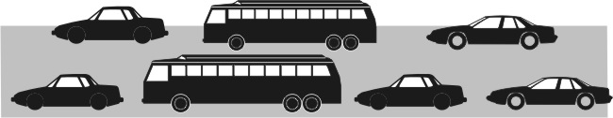

A. 1/2

B. 2/5

**C. 2/7**

D. 5/7

10.

Into how many equal parts should this circle be divided if EXACTLY ¾ of it has to be shaded?

A. 3

**B. 4**

C. 5

D. 7

11.

What should come in the empty box to make the number sentence true?

**A. =**

B. <

C. >

D. We cannot say for sure.

12. I buy 6 bananas and eat half a banana daily. The bananas will be over in

A. 1 day

B. 3 days C. 6 days **D. 12 days**



**Maths**

1. B: Can you see how the rows are filled? We start from the right end of the first row, complete the row with four students, and then again start from the right end of the next row. In the third row, we see 9, 10, 11 and 12, reading from the right. So the fourth row will be 13, 14, 15, 16 reading from the right, (or 16, 15, 14, 13 reading from the left!). Now we have to start with 17 at the right end of the next row, and that is Mihir's seat. So his roll number is 17!

2. B: The second clue says that the number is greater than 300 and less than 400. Of the given options 347 and 396 are between 300 and 400. But 396 does not have 4 as one of its digits. We know from the first clue that Rashi's number has

4 as one of its digits. So Rashi's number is 347.

3. B: Let us first arrange the numbers from SMALL to BIG. Which is the smallest number here? 226. Then we have 236.

Arranging all the numbers we get 226, 236, 262, 326, 431. Now which number is just after 262? 326 isn't it? Note that

236 comes before 262 and not after.

4. D: 374 = 300 + 70 + 4 is it not? This is the same as 300 + 4 + 70. 3 + 4 + 7 = 14 and not 374.

5. D: How do we write a number? The first digit on the right gives the number of ones, the second digit from the right gives the number of tens and the third digit from the right gives the number of hundreds, isn't it? So the given number is 5 hundreds + 3 tens + 2 ones = 532. Remember 352 is 3 hundreds + 5 tens + 2 ones, which is not the same as given in the question.

6. B: Vishal and Shekhar are both adding two numbers. Can you see that the second number of both the boys is the same,

319? That means the first numbers of Vishal and Shekhar are different. Vishal's first number is 465 and Shekhar's first

number is 265. Vishal's first number, 465 is 200 more than Shekhar's first number, 265. So Vishal's answer will be 200 more than Shekhar's answer.

7. B: Let us write down the options as numbers. Option A is 34 ones, that is 34. Option B is 34 tens, that is 340. Option C is

43 tens, that is 430. Option D is 3 hundreds, that is 300. Now which of 34, 340, 430 and 300 is closest to 341? Clearly

340! We cannot answer this question by comparing the numbers 34, 43, etc in the options with 341. We have to write out each of them as numbers.

8. C: Which is the smallest three digit number? 100! Right! Now what number comes after 100? 101 of course! 1000 is the smallest four digit number and does not come just after 100.

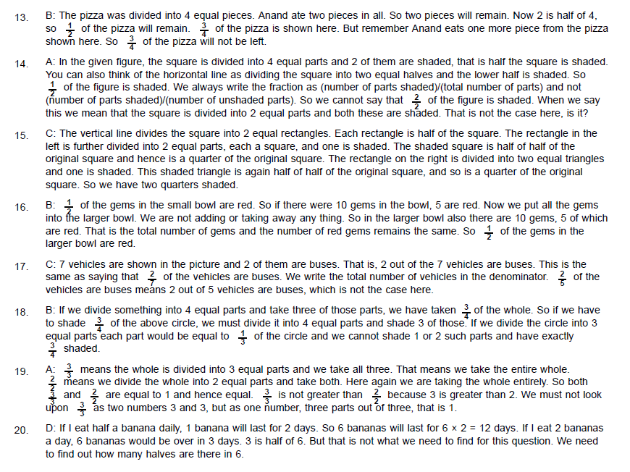

9.

10.



11.



12.